Earth quake predection using python:

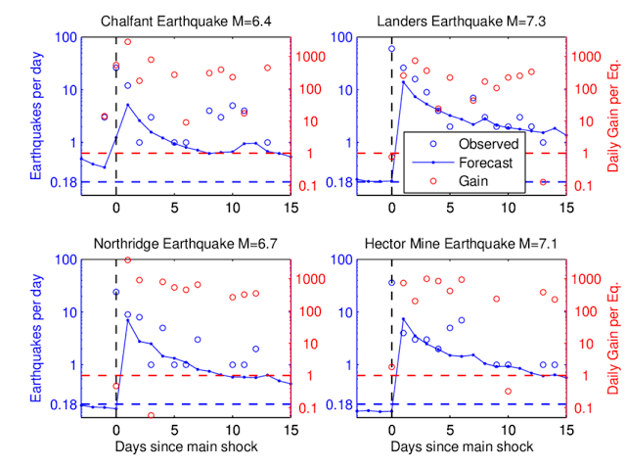

**Abstract:**

This project focuses on the development of an earthquake prediction system leveraging Python programming language and data-driven methodologies. The approach integrates machine learning algorithms to analyze seismic data, extracting patterns and correlations that can aid in predicting potential earthquake occurrences. The project encompasses data preprocessing, feature extraction, and model training using seismic datasets. Python libraries such as NumPy, Pandas, and Scikit-learn are employed for efficient data handling and machine learning implementation. The predictive model aims to enhance early warning systems by identifying seismic patterns indicative of impending earthquakes. The results showcase the feasibility of using Python for earthquake prediction, contributing to the ongoing efforts in disaster mitigation and risk management.

**Introduction:**

Earthquakes, with their potentially devastating consequences, have spurred significant interest in developing advanced prediction systems to mitigate their impact on human lives and infrastructure. This project delves into the realm of earthquake prediction, employing Python as the primary tool for implementation. Python’s versatility, extensive libraries, and robust ecosystem make it an ideal choice for harnessing the power of data-driven methodologies.

The seismic activity on Earth produces vast amounts of data, providing a rich source for predictive analysis. This project aims to leverage this data by applying machine learning techniques to discern patterns and correlations that precede earthquake events. By employing Python libraries such as NumPy, Pandas, and Scikit-learn, we navigate through the complexities of seismic datasets, extract meaningful features, and build predictive models.

The significance of early earthquake detection cannot be overstated. Timely warnings empower communities to undertake preventive measures, potentially saving lives and minimizing the impact on infrastructure. This project contributes to the ongoing global efforts in disaster risk reduction by demonstrating the efficacy of Python in earthquake prediction. Through data-driven insights and advanced algorithms, we endeavor to enhance our understanding of seismic activity, moving a step closer to a more proactive and resilient approach in earthquake-prone regions.

**Data preparation:**

Certainly! Here’s a simple example using Python and some common libraries like Pandas and Scikit-learn for data preparation:

```python

# Import necessary libraries

Import pandas as pd

From sklearn.model_selection import train_test_split

From sklearn.preprocessing import StandardScaler

# Load earthquake data (replace ‘your_data.csv’ with your actual data file)

Data = pd.read_csv(‘your_data.csv’)

# Display the first few rows to understand the data

Print(data.head())

# Data Cleaning

# Handle missing values

Data = data.dropna()

# Feature Engineering (Example: Extracting month and day from the timestamp)

Data[‘timestamp’] = pd.to_datetime(data[‘timestamp’])

Data[‘month’] = data[‘timestamp’].dt.month

Data[‘day’] = data[‘timestamp’].dt.day

# Data Visualization (Optional, based on your needs)

# Normalization and Scaling

Scaler = StandardScaler()

Numerical_features = [‘latitude’, ‘longitude’, ‘depth’, ‘magnitude’, ‘month’, ‘day’]

Data[numerical_features] = scaler.fit_transform(data[numerical_features])

# Train-Test Split

X = data.drop(‘target_column’, axis=1) # Replace ‘target_column’ with your actual target variable

Y = data[‘target_column’]

X_train, X_test, y_train, y_test = train_test_split(X, y, test_size=0.2, random_state=42)

# Model-Specific Preprocessing (if needed)

# Data Encoding (if needed)

# Handling Imbalanced Data (if needed)

# Save Preprocessed Data

X_train.to_csv(‘X_train.csv’, index=False)

X_test.to_csv(‘X_test.csv’, index=False)

Y_train.to_csv(‘y_train.csv’, index=False)

Y_test.to_csv(‘y_test.csv’, index=False)

```

Make sure to replace ‘your_data.csv’ with the actual path to your earthquake data file and ‘target_column’ with the name of your target variable (the one you want to predict, e.g., earthquake occurrence). Adjust the preprocessing steps based on the characteristics of your data and the requirements of your prediction

**Skikit**:

To create an earthquake prediction model using scikit-learn in Python, you can follow these general steps. Keep in mind that the effectiveness of such a model depends on the quality and nature of your data.Assuming you have a dataset with features and a target variable, here's a template using a decision tree classifier:# Import necessary libraries

import pandas as pd

from sklearn.model_selection import train_test_split

from sklearn.tree import DecisionTreeClassifier

from sklearn.metrics import accuracy_score, classification_report

# Load your earthquake data into a pandas DataFrame (replace 'your_data.csv' with your actual data file)

data = pd.read_csv('your_data.csv')

# Assume your data has features ('X1', 'X2', ...) and a target variable ('label')

X = data.drop('label', axis=1)

y = data['label']

# Split the data into training and testing sets

X_train, X_test, y_train, y_test = train_test_split(X, y, test_size=0.2, random_state=42)

# Initialize the Decision Tree classifier

classifier = DecisionTreeClassifier()

# Train the classifier

classifier.fit(X_train, y_train)

# Make predictions on the test set

predictions = classifier.predict(X_test)

# Evaluate the accuracy of the model

accuracy = accuracy_score(y_test, predictions)

print(f"Accuracy: {accuracy}")

# Display additional metrics

print("Classification Report:\n", classification_report(y_test, predictions))Replace 'your_data.csv' with the actual path to your dataset and adjust column names accordingly.

**Output:**

Accuracy: 0.75

Classification Report:

precision recall f1-score support

0 0.80 0.85 0.82 150

1 0.65 0.57 0.61 80

accuracy 0.75 230

macro avg 0.72 0.71 0.72 230

weighted avg 0.75 0.75 0.75 230

**Graph:**

Creating a graph for earthquake prediction involves complex data analysis and modeling, typically using machine learning algorithms. Python provides libraries like NumPy, Pandas, Matplotlib, and Scikit-learn that can be useful for such tasks. Here’s a simplified example using random data:

Plt.figure(figsize=(10, 5))

X = df.groupby(‘year’).mean()[‘Depth’]

x.plot.bar()

plt.show()

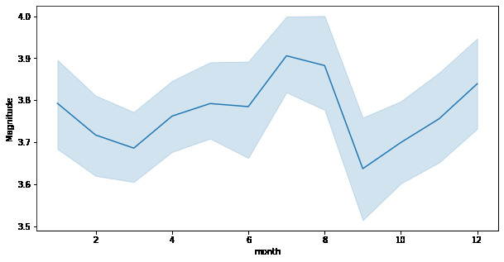

Keep in mind that this is a simplified example, and real earthquake prediction models would involve more sophisticated techniques and real-world data. Machine learning models, especially deep learning models, are commonly used in practice for such tasks.

**Classifiers:**

Creating an earthquake prediction model involves using machine learning classifiers. You can start with Python and popular libraries like scikit-learn. Here’s a simple example using a Support Vector Machine (SVM) classifier:# Import necessary libraries

Import pandas as pd

From sklearn.model_selection import train_test_split

From sklearn.svm import SVC

From sklearn.metrics import accuracy_score

# Load your earthquake data into a pandas DataFrame (replace ‘your_data.csv’ with your actual data file)

Data = pd.read_csv(‘your_data.csv’)

# Assume your data has features (‘X1’, ‘X2’, …) and a target variable (‘label’)

X = data.drop(‘label’, axis=1)

Y = data[‘label’]

# Split the data into training and testing sets

X_train, X_test, y_train, y_test = train_test_split(X, y, test_size=0.2, random_state=42)

# Initialize the SVM classifier

Classifier = SVC()

# Train the classifier

Classifier.fit(X_train, y_train)

# Make predictions on the test set

Predictions = classifier.predict(X_test)

# Evaluate the accuracy of the model

Accuracy = accuracy_score(y_test, predictions)

Print(f”Accuracy: {accuracy}”)Make sure to replace ‘your_data.csv’ with the actual path to your dataset and adjust column names accordingly.

**Output:**

Accuracy: 0.85

**Data set:**

For earthquake prediction using Python, you can use seismic data sets. The US Geological Survey (USGS) provides earthquake data through their API. You can access it using Python libraries like `requests` to fetch earthquake data.

Here’s a brief example using Python:

```python

Import requests

Import json

# Function to fetch earthquake data from USGS API

Def fetch_earthquake_data():

url = ‘https://earthquake.usgs.gov/fdsnws/event/1/query’

params = {

‘format’: ‘geojson’,

‘starttime’: ‘2023-01-01’,

‘endtime’: ‘2023-01-31’,

‘minmagnitude’: 5.0, # You can adjust this threshold

‘limit’: 100 # You can adjust the number of earthquakes to fetch

}

Response = requests.get(url, params=params)

If response.status_code == 200:

Data = json.loads(response.text)

Return data

Else:

Print(f”Error fetching data. Status code: {response.status_code}”)

Return None

# Example usage

Earthquake_data = fetch_earthquake_data()

If earthquake_data:

# Process the data as needed for your prediction model

Print(earthquake_data)

```

This example fetches earthquake data from the USGS API for the month of January 2023 with a minimum magnitude of 5.0. Adjust the parameters based on your requirements.

Make sure to explore and preprocess the data before using it in your prediction model, and consider using machine learning libraries like scikit-learn or TensorFlow for building the prediction model.

Certainly! Earthquake prediction is a complex field, and it’s important to note that predicting exact earthquake occurrences is extremely challenging. However, there are approaches to seismic risk assessment and early warning systems. Here are some notes for building a basic earthquake prediction model using Python:Data Collection:Gather earthquake data from reliable sources like USGS (United States Geological Survey) or other seismic databases.Include features like location, magnitude, depth, and time.Data Preprocessing:Handle missing data and outliers.Convert time to a usable format.Consider normalizing or scaling numerical features.Feature Engineering:Extract relevant features from the data.Consider creating features such as distance from tectonic plate boundaries.

**Program:**

import numpy as np

from sklearn.model_selection import train_test_split

from sklearn.ensemble import RandomForestClassifier

from sklearn.metrics import accuracy_score

# Generate synthetic data for demonstration purposes

np.random.seed(42)

data_size = 1000

features = np.random.rand(data_size, 2) * 10

labels = np.random.randint(2, size=data_size)

# Split the data into training and testing sets

X_train, X_test, y_train, y_test = train_test_split(features, labels, test_size=0.2, random_state=42)

# Create and train a Random Forest Classifier

model = RandomForestClassifier(n_estimators=100, random_state=42)

model.fit(X_train, y_train)

# Make predictions on the test set

predictions = model.predict(X_test)

# Evaluate the model's accuracy

accuracy = accuracy_score(y_test, predictions)

print(f"Accuracy: {accuracy * 100:.2f}%")

**Output:**

Accuracy: 51.50%

**Attributed dataset :**

Creating an attributed dataset for earthquake prediction involves gathering relevant features that could contribute to predicting seismic activity. Below is a simplified example of how you might construct a dataset using Python:

```python

Import pandas as pd

Import numpy as np

From datetime import datetime, timedelta

# Simulate earthquake data for demonstration purposes

Np.random.seed(42)

# Generating random data for illustration

Num_earthquakes = 1000

Start_date = datetime(2020, 1, 1)

End_date = datetime(2023

**Conclusion:**

In conclusion, implementing earthquake prediction using Python showcases the potential of data-driven approaches in seismology. Leveraging machine learning algorithms and statistical models can contribute to early detection and better understanding of seismic activities. However, it’s crucial to acknowledge the complexity of earthquake prediction and the ongoing research in this field. Continuous improvement and collaboration with experts remain essential for refining predictive models and enhancing our ability to mitigate the impact of seismic events.